Supporting SEND at St. Aloysius College
St. Aloysius College is an inclusive school where staff are committed to supporting the needs and aspirations of all our pupils. We believe that all children have the right to a broad and balanced education, one which allows them to flourish and grow as an individual. Ensuring equality of opportunity and equity requires more than simply treating everybody in the same way, our aim and vision is understanding and tackling the different individual barriers and challenges a pupil may face.
As a school, we recognise the importance of not only supporting children’s academic progress but also developing their behavioural, emotional and social skills to enable them to become confident, independent learners.
Our Vision
- An inclusive culture – no one left behind
- Reducing the gaps – academic progress, attendance, exclusions
- Staff, pupils and parents working collaboratively
- Leadership focus on building capacity and developing specialisms within the team

I invite you to read our school Information report and policy which describes in detail how we identify pupils who have special educational needs and our use of the graduated approach to support their progress and development.
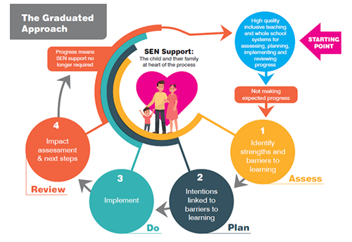https://www.lancashire.gov.uk/media/922347/chapter-3-the-graduated-approach.pdf
We support children and young people with a range of special educational needs that fall under each of the four broad categories of need.
- Communication and interaction: e.g. Speech, Language and Communication Needs (SLCN), Autism Spectrum Disorder (ASD), Asperger’s Syndrome
- Cognition and learning: e.g. Specific Learning difficulties (SpLD) which includes Dyslexia, Dyscalculia and Dyspraxia, Moderate Learning Difficulties (MLD), Severe Learning Difficulties (SLD) global developmental delay.
- Social, emotional and mental health difficulties (SEMH): e.g. Attention Deficit Hyperactive Disorder (ADHD), Depression, Anorexia, Anxiety.
- Sensory and/or physical needs: e.g. Vision Impairment (VI), Hearing Impairment (HI), Medical needs
If a pupil is identified as having special educational needs, we will consider everything we know about the pupil to determine the support that they need. The support the school provides is then offered in the following steps:
1. Inclusive quality first teaching
This is the quality first teaching your child will receive from their subject teachers and may include some minor adaptations and differentiation to match your child’s learning needs.
All teachers and support staff hold relevant knowledge and experience to meet the needs of your child. All pupils who are on the additional needs register have a learning profile which is shared with the staff that teach and support them. This profile outlines their individual needs and the specific strategies that must be used to support their progress in and outside of the classroom.
2. Targeted, catch up provision
Specific targeted one to one or small group interventions may be run outside the classroom. These will be limited to a set period of time to minimise disruption to the regular curriculum. You and their class teachers will be kept informed of your child’s progress towards the learning outcomes of the interventions they participate in.
3. Specialist intervention
It may be necessary to seek specialist advice and regular long-term support from a specialist professional outside the school in order to plan for the best possible learning outcomes for your child. This may include for example educational psychology, speech and language therapy, occupational therapy and sensory advisory teachers. The school may need to prioritise referrals to these services. However, for a small number of pupil’s access to these specialists may be guaranteed through an Educational Health Care plan.
Please click on the following link: https://www.sta.islington.sch.uk/our-school/policies-and-documents to view our SEND Information Report and Policy for 2023-2024
To contact Islington Council's SEND team, attend events and join the Islington Parent Forum, please follow the link https://www.islington.gov.uk/children-and-families/send-local-offer#

Meet the Learning Support Team
The Learning Support department team is comprised of staff with a range of skills, experience and knowledge. The team receive continuing professional development so that they are able to differentiate fully for the varying needs of a range of students on the additional needs register.
Ms. Braja (QTS) | MA SENDCo; English Teacher
Ms. Jastrzab (QTS) | Deputy SENDCo; HoY7
Ms. Hunter | Learning Support Assistant and SEND Admin support
Mr. Salazar | Learning Support Assistant and Humanities specialist
Mr. Mcintosh | Learning Support Assistant and Maths specialist
Mr. Widowson | Learning Support Assistant and Science specialist
Miss. Oechler | Learning Support Assistant and English specialist
Ms. Benkahla | Learning Support Assistant and Maths specialist

External Support Agencies
The Learning Support department maintains strong and productive relationships with a range of local services. These include Islington Educational Psychology service, Mental Health in School Support Team, Child and Adolescent Mental Health Services (CAMHS), the School Health Service, Islington Sensory Service and Lambeth Autism Advisory Service.

Working with Parents/Carers and Families
We recognise the importance of building and developing supportive and effective relationships with the parents of children with SEND attending our school. Please do get in contact if you would like to discuss the needs of your child or any additional support you feel they may need.
SENDCO
Deputy SENDCO

Useful Links

Here are some links to useful websites related to SEND:
- Special Needs Jungle, Parent Information and Support Website https://www.specialneedsjungle.com/category/send/
- British Dyslexia Association http://www.bdadyslexia.org.uk/
- National Autistic Society https://www.autism.org.uk/
- ADHD UK https://adhduk.co.uk/about-adhd/
- The Communication Trust https://ican.org.uk/i-cans-talking-point/professionals/tct-resources/
- Islington SEND Local Offer: https://www.islington.gov.uk/children-and-families/send-local-offer

