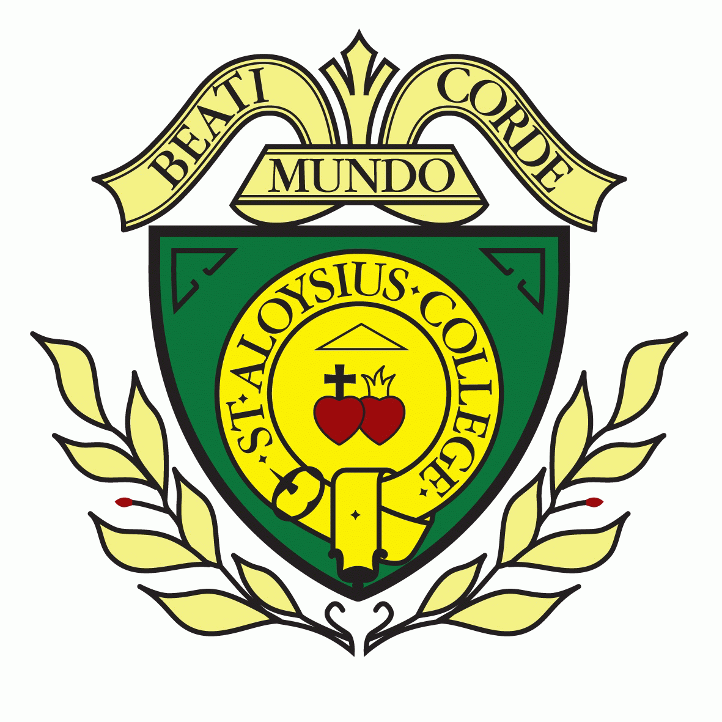

Students Consent Form for Taking and Using Photos, Videos etc.

2023-24

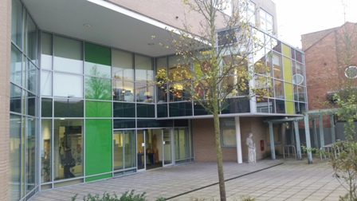
Person responsible | SBM/  A Charlemagne
Last Review Date | January 2023
Next Review | January 2024
This policy is communicated by the following means: | School website
Chair of Governors Signature:

St Aloysius’ College
Hornsey Lane,
Highgate,
London
N6 5LY
Student’s Consent form for taking and using photos, film etc.

Student’s name: ___________________________________ (capitals please)

We require consent from you for the school to be able to use your personal data other than for educational purposes or for purposes relating to your safety and wellbeing, etc. We sometimes use information, photos, videos etc for other reasons, including celebrating students’ achievements and promoting the school. We take care of your information and images, as set out in our Privacy Notice and safeguarding policy, available [on the school website https://www.sta.islington.sch.uk/attachments/download.asp?file=811&type=pdf]. We would like to ask your consent for the following activities and purposes.
Please tick yes or no for each statement and return this form to [your form tutor/the school office].
 | Yes | No
I give permission for my photograph to be used within the school for display purposes
I give permission for my name/photograph/work to be included in the school newsletter
I give permission for my name/photograph/work to be used on the school website
I give permission for my name/photograph/work to be used in other school publications (e.g. prospectus, leavers’ books, class and open evening displays)
I give permission for my name/image to be used on the school’s social media websites (e.g. Twitter, Facebook Instagram etc)
I give permission for my image to be used in the media (e.g. local press)
I give my permission to be filmed for school assemblies, productions etc and the film to be placed on the school website/made available for sale to parents
I give my permission to be included in the school class photograph and I understand that this printed/digital photo can be purchased by parents/carers
I give permission for my photograph to be shared with the Diocese of Westminster (e.g. for use in its schools’ newsletter)
I give permission for selected photographs and/or video of me to be kept for longer than the standard period in the school’s data retention policy, for historical (archiving) purposes

Student’s signature …………………………………………………………………

Please print name here…………………………… Date …………………………

NB: Consent can be withdrawn at any time. Please email enquiries@sta.islington.sch.uk, call the school on 020 7561 7800, or just popping in to the school office.

Please note that we take photos of all new pupils for their computer record which is an important safeguarding measure

