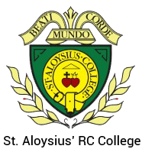
ST ALOYSIUS’ COLLEGE
SUPPLEMENTARY INFORMATION (Faith criteria application)

Child’s Details
Child’s surname: | Child’s Christian or other first name:
Home Address: | Present School:
Postcode: | Date of Birth:
Parent/Carer Details
Parent(s)/Carer(s) Full Name: | Telephone number:
 | Email Address:
Address (if different from above):
Alternative Contact Name: | Telephone number:
 | Email Address:
Address:

Religion of Child (please tick one)
Catholic | Other Christian (please state name of denomination e.g Methodist) |  |  | Other Faith
Catholic Parish you live in:
Church where child was baptised and date of baptism:
Please attach a photocopy of your child's Baptismal Certificate.
Name and Address of your place of regular worship
(if not Catholic):
Name and position of priest providing Certificate of Catholic Practice or religious leader supplying letter confirming membership of the faith community (where appropriate):
Names of brothers or sisters at this school: |  | Class or Year Group of Sibling:
Is your child ‘looked after’ by the Local Authority, adopted or subject to a ‘child arrangements’ or special guardianship order having previously been ‘looked after’? (Please circle) |  |  | YES |  | NO

I confirm that I have read and understood the Admissions Policy and that the information I have provided is correct. I understand that I must notify the school immediately if there is any change to these details and that should any information I have given prove to be inaccurate that the governors may withdraw any offer of a place even if the child has already started school.

Signed……………………………………………………………… Date…..…………………

Please note:  Where applicable parents can obtain a Certificate of Catholic Practice from the priest at the parish where the family normally worships or from the Diocese of Westminster website at www.rcdow.org.uk/schools (follow ‘for parents’ if applying for a place under the “practicing Catholic” criteria)  Applicants from other Christian denominations and other faiths may attach a letter from their minister or religious leader confirming membership of the faith community.  You must complete your local authority’s Common Application Form on line If you do not do this you will not be offered a place | Checklist: Have you enclosed?  Copy of baptism certificate (where necessary)  Certificate of Catholic Practice (where necessary)  Letter confirming membership of a Faith community from a religious leader  Evidence of exceptional need (where appropriate)  Have you completed your local authority’s Common Application form

The school is committed to protecting the information provided by parents/carers and using it only for the purpose for which it was obtained. For information on the school’s Privacy Notice please look on the school website under Privacy Notice or contact the school for a hard copy
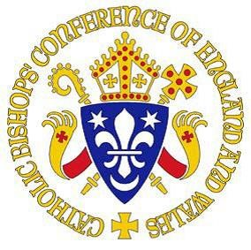

BISHOPS’ CONFERENCE OF ENGLAND AND WALES

CERTIFICATE OF CATHOLIC PRACTICE

Details of child (for identification only)
Full name of child: ____________________________________________________
Address of child: _____________________________________________________
___________________________________________________________________
Postcode: ___________________ Date of Birth: ____________________________

I am [the child’s parish priest] [the priest in charge of the Church where the family practises] [delete as applicable]
I hereby certify that this child and his/her family are known to me and, to the best of my knowledge and belief, the child is from a practising Catholic family.

Priest’s name ____________________ Position ___________________________
Parish (or ethnic chaplaincy) ____________________________________________
Address ____________________________________________________________
___________________________________________________________________

Telephone_______________________
Priest’
s signature__________________________
_____
____________
_

Parish stamp or seal

Date_____________

